64. Modeling of carburetor
Abstract:
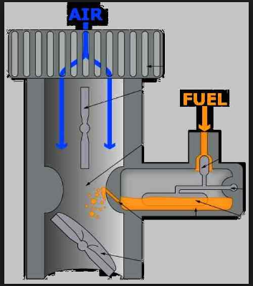
Simple carburetor
Carburetor is a device that blends air and fuel for an internal combustion engine. This device is used in petrol or similar liquid fuel engines by means of which the fuel mixed with air is supplied into the induction manifold of the engine. The carburetor controls the required quantity of fuel and breaks it up into minute globules for being mixed with the correct quantity of air.
The main purpose of carburetor is to supply the required quantity of petrol and air mixture, of the correct strength as per requirement of load conditions of the engine. The ratio should not be more than 20:1 and not less than 8:1.The ideal ratio is 15: 1
This is most important to supply proper air-fuel ratio in inlet manifold of the internal combustion engine. The process of breaking up the fuel into minute particles and mixing it with air is known as carburetion.
In carburetor, the fuel is completely broken into the minute particles, vaporized and mixed with the air in a proper ratio. The homogeneous mixture of fuel and air thus obtained is supplied to the engine cylinder during the suction stroke of engine.
In this project we design the model carburetor and its parts.

